

**[Topic]**

**Bachelor Thesis / Master Thesis / Diploma Thesis / Seminar Paper**

in Business Administration/International Business Administration/

European Business Administration/Business and Economic Education

at the Department of Social and Economic Sciences

Otto-Friedrich-University Bamberg

Chair: Business Administration, esp. Innovation Management

Head of Chair: Professor Dr. Alexander Fliaster

Adviser: [xxx]

Author: [Name Surname]

Matriculation Number: [xxx]

Address: [Street, Area Code City]

E-Mail: [xxx@stud.uni-bamberg.de]

Field of Study: [e.g. Business Administration, Bachelor’s Degree]

[x. term of studying in this field/ x. term at university]

Date of Submission: [MM/DD/YYYY]

**Abstract**

**Outline**

List of Abbreviations II

(if applicable) List of Symbols III

List of Figures IV

List of Tables V

1 Introduction to the Topic 1

1.1 [Heading of the subchapter] 1

1.2 [Heading of the subchapter] 1

1.2.1 [Paragraph of a subchapter] 1

1.2.2 [Paragraph of a subchapter] 2

1.3 [Heading of the subchapter] 2

1.3.1 [Paragraph of a subchapter] 2

1.3.1.1 [Further level of the structure] 2

1.3.1.2 [Further level of the structure] 2

1.3.2 [Paragraph of a subchapter] 2

Bibliography VI

(if applicable) Appendix VII

# List of Abbreviations

|  |  |
| --- | --- |
|  |  |
| KBV | Knowledge-based view |
| RBV | Resource-based view |
| …. | …. |
| …. | …. |
| …. | …. |
| …. | …. |

# (if applicable) List of Symbols

# List of Figures

Figure 1: Phase Model of Path Dependencies 1

Figure 2: Stakeholder Typology 2

# List of Tables

Table 1: Differences between Traditional Service and Contract Service 3

# 1 Introduction to the Topic

[Body]

## [Heading of the subchapter]

….

….

….

….

## [Heading of the subchapter]

….

….

….

….

### [Paragraph of a subchapter]

[Body]



Figure 1: Phase Model of Path Dependencies

Source: Sydow/Schreyögg/Koch (2009), p. 692

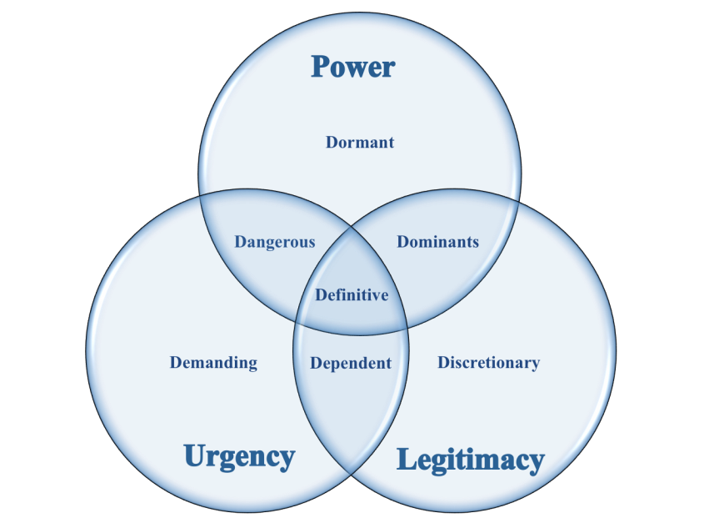

Figure 2: Stakeholder Typology

Source: Own illustration; following Mitchell/Agle/Wood (1997), p. 872

[Text Body]

### [Paragraph of a subchapter]

[Text Body]

## [Heading of the subchapter]

[Text Body]

### [Paragraph of a subchapter]

[Text Body]

#### [Further level of the structure]

#### [Further level of the structure]

### [Paragraph of a subchapter]

[Text Body]

Table 1: Differences between Traditional Service and Contract Service

Source: cf. Razzaque/Shang (1998), p. 91

|  |  |
| --- | --- |
| **Traditional services** | **Contract services** |
| Not tailored | Tailored |
| Usually one-dimensional – trucking or warehousing for example | Are multi-dimensional, linking transportation, warehousing, inventory management, systems and others |
| Shippers aim to lower transportation cost through a contract | Goal is to lower total cost while providing better service and more flexibility |
| Contracts tend to run for a year or two | Contracts are more likely to be of longer duration, multi-year arrangements negotiated at a higher management level |
| Require expertise in, say, transportation of packaged materials | Requires broad logistics and analytical skills |
| Contracts generally take less time to negotiate | Contracts generally take more time to negotiate |
| Simpler arrangement and relatively low switching costs | Complexity of arrangements leads to higher switching costs |

……….

……….

# Bibliography

Berger, Doris (2010): Wissenschaftliches Arbeiten in den Wirtschafts- und Sozialwissenschaften. Hilfreiche Tipps und praktische Beispiele. Wiesbaden: Gabler.

Bogner, Alexander/Menz, Wolfgang (2009): Das theoriegenerierende Experteninterview, in: Bogner, Alexander/Littig, Beate/Menz, Wolfgang (Ed.): Experteninterviews, 3rd Edition. Wiesbaden: VS Verlag für Sozialwissenschaften, p. 61-98.

Dearstyne, Bruce W. (2005): Blogs – The New Information Revolution?, in: Information Management Journal, 39 (5), p. 38-44.

Ebster, Claus/Stalzer, Liselotte (2008): Wissenschaftliches Arbeiten für Wirtschafts- und

Sozialwissenschaften, 3rd Edition. Wien: UTB GmbH.

Kawamura, Yuniya (2005): Fashion-ology – An Introduction to Fashion Studies, 2nd Edition. New York (USA): Berg Publishers.

Kotler, Philip (1979): Marketing für den öffentlichen Bereich. Ansatzpunkte, Instrumente und Anwendungsbeispiele, in: Die Betriebswirtschaft, Volume 39, Issue 3, p. 421-430.

Mey, Günther (2007): Qualitative Interviews, in: Naderer, Gabriele/Balzer, Eva (Ed.): Qualitative Marktforschung in Theorie und Praxis, 2nd Edition. Wiesbaden: Gabler Verlag, p. 247-278.

Mitchell, Ronald K./Agle, Bradley R./Wood, Donna J. (1997): Toward a Theory of Stakeholder Identification and Salience, in: Academy of Management Review, 22 (4), p. 853-886.

O’Reilly, Tim (2005): What is the Web 2.0?, URL: http://www.oreilly.de/artikel/web20.html, May 14th 2011.

Razzaque, Mohammed A./Sheng, Chang C. (1998): Outsourcing of Logistics Functions: A Literature Survey, in: International Journal of Physical Distribution & Logistics, Volume 28, Issue 2, p. 89-107.

Stickel-Wolf, Christine/Wolf, Joachim (2011): Wissenschaftliches Arbeiten und Lerntechniken. Erfolgreich studieren – gewusst wie!, 6th Edition. Wiesbaden: Gabler.

Sydow, Jörg/Schreyögg, Georg/Koch, Jochen (2009): Organizational Path Dependence: Opening the Black Box, in: Academy of Management Review, 34 (4), S. 689-709.

Theisen, Manuel R. (2008): Wissenschaftliches Arbeiten, Technik - Methodik - Form, 14th Edition. München: Vahlen.

# (if applicable) Appendix

**Declaration**

*The correct statement of declaration should be used from the confirmation letter of the bachelor / master thesis (“Thema-Bestätigung”) following the examples stated below:*

[Obligatory for: Business Administration Bachelor’s Degree/European Business Administration Bachelor’s Degree/Business Administration Master’s Degree/European Business Administration Master’s Degree/Business and Economic Education Master’s Degree]

Ich erkläre hiermit gemäß § 6 Abs. 3 PO, dass ich die vorstehende Bachelorarbeit/Masterarbeit selbständig verfasst und keine anderen als die angegebenen Quellen und Hilfsmittel benutzt habe.

[Obligatory for: International Business Administration Bachelor’s Degree/ International Business Administration Master’s Degree]

Ich erkläre hiermit gemäß § 5 Abs. 3 PuStO, dass ich die vorstehende Bachelorarbeit/Masterarbeit selbständig verfasst und keine anderen als die angegebenen Quellen und Hilfsmittel benutzt habe.

[Obligatory for: Diploma Business Administration/Diploma European Business Administration/Diploma Business and Economic Education]

Ich erkläre hiermit gemäß § 27 Abs. 2 APO, dass ich die vorstehende Diplomarbeit selbständig verfasst und keine anderen als die angegebenen Quellen und Hilfsmittel benutzt habe.

[Obligatory for: Seminar Papers]

Ich/Wir erkläre/erklären hiermit, dass ich/wir die vorstehende Seminararbeit selbständig verfasst und keine anderen als die angegebenen Quellen und Hilfsmittel benutzt habe/haben.

City/Date Signature