### 

**[Topic]**

**Bachelor Thesis / Master Thesis / Seminar Paper**

in Business Administration/International Business Administration/

European Business Administration/Business and Economic Education

at the Department of Social and

Economic Sciences

Otto-Friedrich-University Bamberg

Module: [only specify for seminar paper, e.g. Research Seminar on International Innovation Strategies]

Chair: Business Administration, esp. Innovation Management

Head of Chair: Professor Dr. Alexander Fliaster

Adviser: [xxx]

Author: [Name Surname]

Matriculation Number: [xxx]

Address: [Street, Area Code City]

E-Mail: [xxx@stud.uni-bamberg.de]

Field of Study: [e.g. Business Administration, Bachelor’s Degree]

[x. term of studying in this field/ x. term at university]

Date of Submission: [MM/DD/YYYY]

****Abstract****

**Table of contents**

List of Abbreviations II

(if applicable) List of Symbols III

List of Figures IV

List of Tables V

1 Introduction to the Topic 1

1.1 [Heading of the subchapter] 1

1.2 [Heading of the subchapter] 1

1.2.1 [Paragraph of a subchapter] 1

1.2.2 [Paragraph of a subchapter] 2

1.3 [Heading of the subchapter] 2

1.3.1 [Paragraph of a subchapter] 2

1.3.2 [Paragraph of a subchapter] 2

2 [Main Section] 2

Bibliography VI

List of Annexes VII

Annex VIII

List of Abbreviations

|  |  |
| --- | --- |
| KBV | Knowledge-based view |
| RBV | Resource-based view |
| …. | …. |
| …. | …. |
| …. | …. |
| …. | …. |

(if applicable) List of Symbols

|  |  |
| --- | --- |
| **Symbol** | **Description** |
| m | mass |
| T | time |
| …. | …. |
| …. | …. |
| …. | …. |

List of Figures

Figure 1: Phase Model of Path Dependencies 2

Figure 2: Stakeholder Typology 2

List of Tables

Table 1: Differences between Traditional Service and Contract Service 2

# Introduction to the Topic

[This is an example text to show how paragraphs should look like. A new paragraph is indicated by starting a new line.

So, this should look like this. Text text text text text text text text text text text text text text text text text text text text text text text text text text text text text]

## [Heading of the subchapter]

…

…

…

…

## [Heading of the subchapter]

…

…

…

…

### [Paragraph of a subchapter]

[Body]



Figure 1: Phase Model of Path Dependencies

Source: Sydow et al. (2009), p. 692

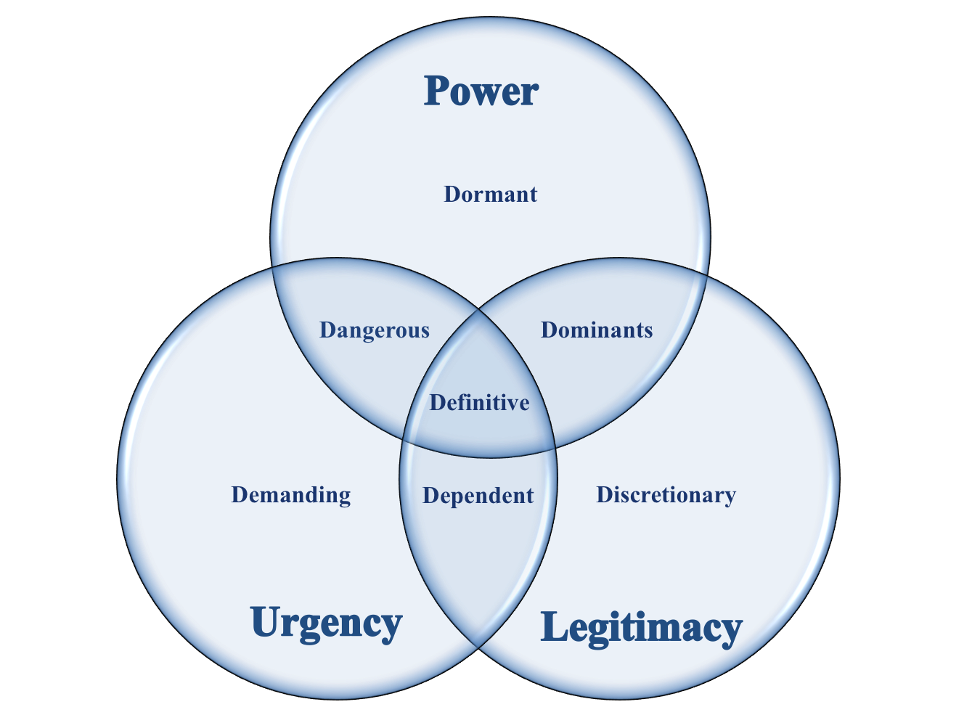

Figure 2: Stakeholder Typology

Source: Author’s own based on Mitchell et al. (1997), p. 872

[Text Body]

### [Paragraph of a subchapter]

[Text Body]

## [Heading of the subchapter]

[Text Body]

### [Paragraph of a subchapter]

[Text Body]

### [Paragraph of a subchapter]

[Text Body]

# [Main Section]

[Text Body]

[Text Body]

[Text Body]

[Text Body]

[Text Body]

Table 1: Differences between Traditional Service and Contract Service

Source: Razzaque & Shang (1998), p. 91

|  |  |
| --- | --- |
| **Traditional services** | **Contract services** |
| Not tailored | Tailored |
| Usually one-dimensional – trucking or warehousing for example | Are multi-dimensional, linking transportation, warehousing, inventory management, systems and others |
| Shippers aim to lower transportation cost through a contract | Goal is to lower total cost while providing better service and more flexibility |
| Contracts tend to run for a year or two | Contracts are more likely to be of longer duration, multi-year arrangements negotiated at a higher management level |
| Require expertise in, say, transportation of packaged materials | Requires broad logistics and analytical skills |
| Contracts generally take less time to negotiate | Contracts generally take more time to negotiate |
| Simpler arrangement and relatively low switching costs | Complexity of arrangements leads to higher switching costs |

Bibliography

Gioia, D. A., Corley, K. G., & Hamilton, A. L. (2012). Seeking qualitative rigor in inductive research: Notes on the Gioia methodology. *Organizational Research Methods, 16*(1), 15- 31. https://doi.org/10.1177/1094428112452151

Gläser, J., & Laudel, G. (2010). *Experteninterviews und qualitative Inhaltsanalyse: Als Instrumente rekonstruierender Untersuchungen* (4. Auflage). VS Verlag für Sozialwissenschaften.

Glaser, B. G., & Strauss, A. L. (2012). *The discovery of grounded theory: Strategies for qualitative research* (7th ed.). Transaction Publishers.

Misoch, S. (2019). *Qualitative Interviews* (2. Auflage). De Gruyter Oldenbourg.

Tiwana, A. (2008). Do bridging ties complement strong ties? An empirical examination of alliance ambidexterity. *Strategic Management Journal, 29*(3), 251–272. https://doi.org/10.1002/smj.666

Yin, R. K. (2018). *Case study research: Design and methods* (6th ed.). Sage publications.

List of Annexes

Annex 1: Interview guidelines II

Annex 2: Overall concept II

Annex

##### Annex 1: Interview guidelines

Source: Author’s own

Preliminary note

The aim of my survey is to…

1. Question
2. Question
3. …

##### Annex 2: Overall concept

Source: Author’s own

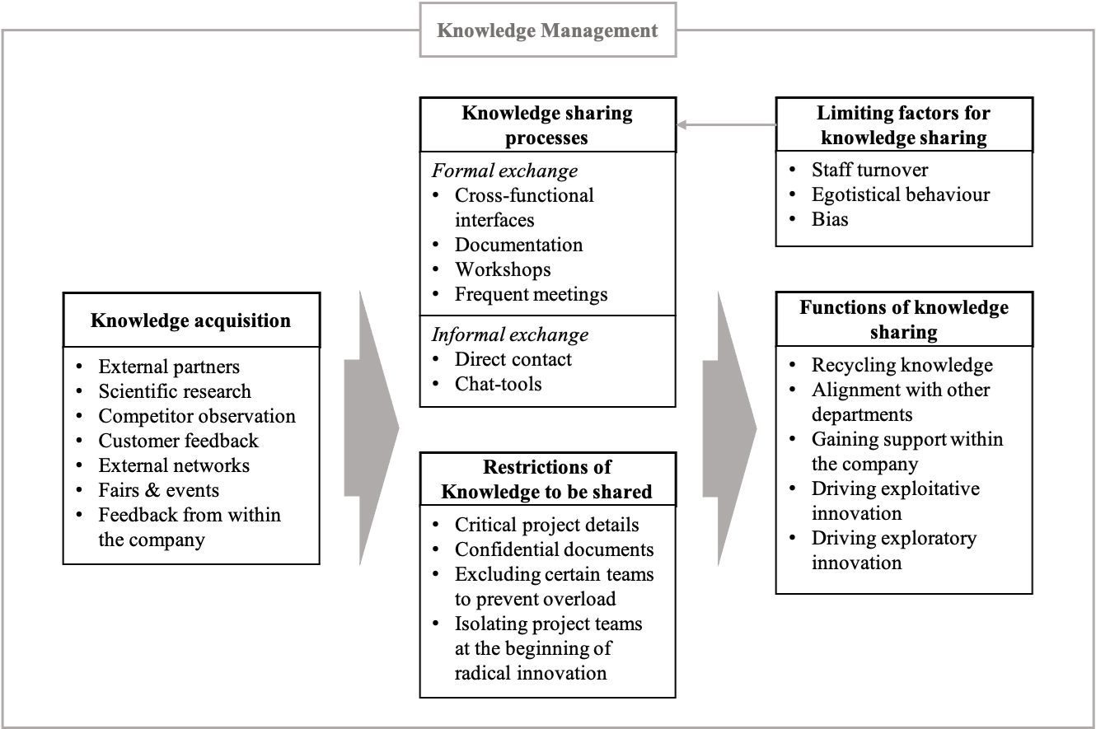

Declaration of academic integrity

I hereby declare, in accordance with § 6 (6) of the General Examination Rules (Allgemeine Prüfungsordnung, APO) of the University of Bamberg, that I have prepared the above *Bachelor’s/Master’s/term paper [“Title of the Paper”]* as well as the presentation materials for the oral presentation entirely on my own without external assistance, that it has not been submitted, in whole or in part, as an examination before, and that I have used no sources or tools other than those listed. All direct quotations and paraphrases have been clearly indicated, and material from the work of others has been appropriately acknowledged. This also applies to inserted figures and similar materials. Furthermore, I declare that the digital version of the printed copy of the *[Bachelor /Master thesis /term paper]* corresponds completely in content and wording to the printed version, and I understand that this digital version may be subjected to a software-supported, anonymized check for plagiarism.  
*(Bachelor’s and Master’s theses should be supplemented at this point with the wording of the topic confirmation form)*

I further declare that I have used text or other content-generating artificial intelligence (AI) software (e.g. ChatGPT) only with the permission of my examiner, and that I have noted this in the reference section under "Tools". I declare that I have used the AI in accordance with the Rules for the Use of AI at the University of Bamberg (<https://www.uni-bamberg.de/cio/ki/> - only available in German).

I hereby also declare that I have informed all persons surveyed as part of the data collection process about the data protection regulations in force at the University of Bamberg (<https://www.uni-bamberg.de/datenschutz/datenschutz-information/> - only available in German) and have obtained explicit consent from all individuals for the processing of their information and personal data in accordance with BayHSchG Art. 2 (1) by the Chair of Business Administration, especially Innovation Management at the Otto-Friedrich-Universität Bamberg. This includes explicit consent for the use of the collected data for research projects and publication projects at the Chair of Business Administration, especially Innovation Management. *(if not applicable, please remove this paragraph)*

City/Date Signature